Data Element Validation (DEV) Guidebook
Step-by-Step Instructions

- Put together a notebook that includes the latest TEGL on DEV

- Login to DOL DVRS system on CCWD Laptop. Password is WIAAdmin.
Click on the funding stream (A, DW, NEG, etc.) that you will be validating, click on Data Element Validation on the top tool bar, click on Sub-Sample in the drop down, click on Validate Sub Sample, then select appropriate Sub-Sample funding stream again. The participant’s name you will need to look up in step 4 is located in the box entitled “User Field 2”.

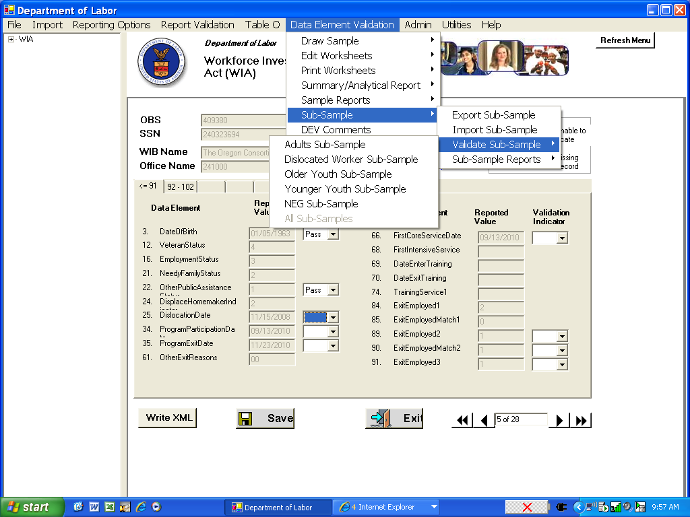

- Open the DEV data worksheet(s) that you get from Lori Allen for the data you are validating--Youth, Adults, DWs, and NEGs. Youth are really the only files that need to be validated in the field due to DOL requirements of looking at actual, hard-copy documents. Select using the tab at the bottom of the page the region that you will be validating. Find the participant name whose file you are validating and select his or her Job Seeker (JS) ID. Copy the JS #.

- Log into WOMIS (get a user name and password from Gus Johnson at OED if you don’t already have one A.Gus.JOHNSON@state.or.us). Click on “WIA Management Information System” link.

- Click on Participant Search in upper left hand corner and paste JS # into the box entitled “Job Seeker ID”.

- Click on correct name and validate Date of Birth, Veteran Status, and Low Income status.

- To validate DOB (actual DOB is at upper, right of page) and Low Income, look under Welcome Process Status for “DOB validated, Date, and ID reviewed by staff. To validate if Low Income, look under Eligibility. This should match the coding in the DVRS.

- To validate Program Participation Date and Program Exit Date first open spreadsheet you get from Lori Allen. Look up participant in the spreadsheet under appropriate region. It will show the start source and the exit source then use http://ccwd/ccwdIntranet/devreports.aspx to validate using Job Seeker ID to search.

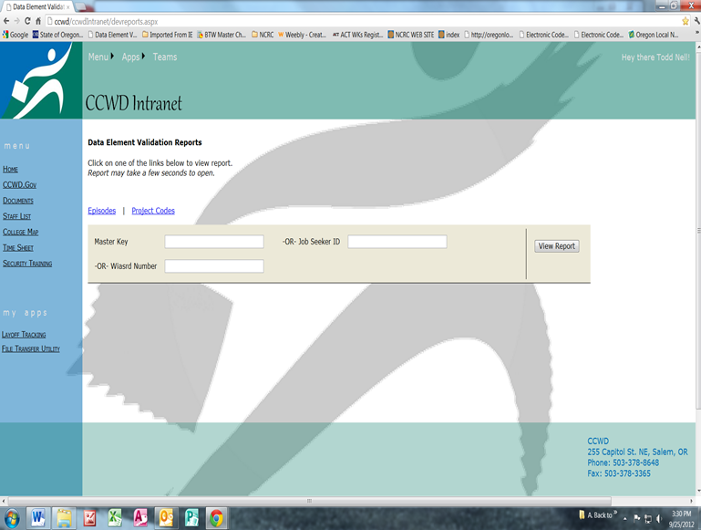

- If you are unable to validate (find the date of service listed), go back to the to “Search Results” by clicking on link on left side of screen (see green arrow two pictures back). Then, click on “yes” under “WIA-MIS Enrollment”.

- Look under both the “Enrollments” tab and the “Services” tabs to validate:
Veteran’s Status, Employed at Exit, Low Income, Additional Public Assistance (Food Stamps), Barriers (Displace Homemaker), and Dislocation date. You can click on the graph as shown by the blue arrow below to check and validate many of the elements on the report that comes up.

Under the Services tab you can validate Participation Date, First Core Service Date, First Intensive, Training, and Exit dates.

- In order to Validate accurately, you should always think that the element SHOULD be passed. It is VERY rare that you would fail an element. If you think you should Fail an element, check with Lori Allen. Explain why you think the element is a fail and she will help trouble shoot things.

- I would recommend that you have three screens (one wide screen split in half, and a separate second screen installed on your desk) and pull up the information as follows. This allows for more efficient gathering of data.

